Together Fund Mapping: Areas of Focus

Bath & North East Somerset
Priority areas as identified by mapping and collaboration with VCFSE Partners:
- Radstock
- Midsomer Norton
- Twerton
- Paulton
Long-term health conditions & disability
- Keynsham South
  - 1173 people whose day-to-day activities are limited
  - No targeted projects ever funded through TIF
- Midsomer Norton Redfield & North
  - 1851 people whose day-to-day activities are limited
  - £2368 spent on Zumba classes for people within this group
- Weston
  - 1010 people whose day-to-day activities are limited
  - No targeted projects ever funded through TIF
- Twerton
  - 1112 people whose day-to-day activities are limited
  - No targeted projects ever funded through TIF
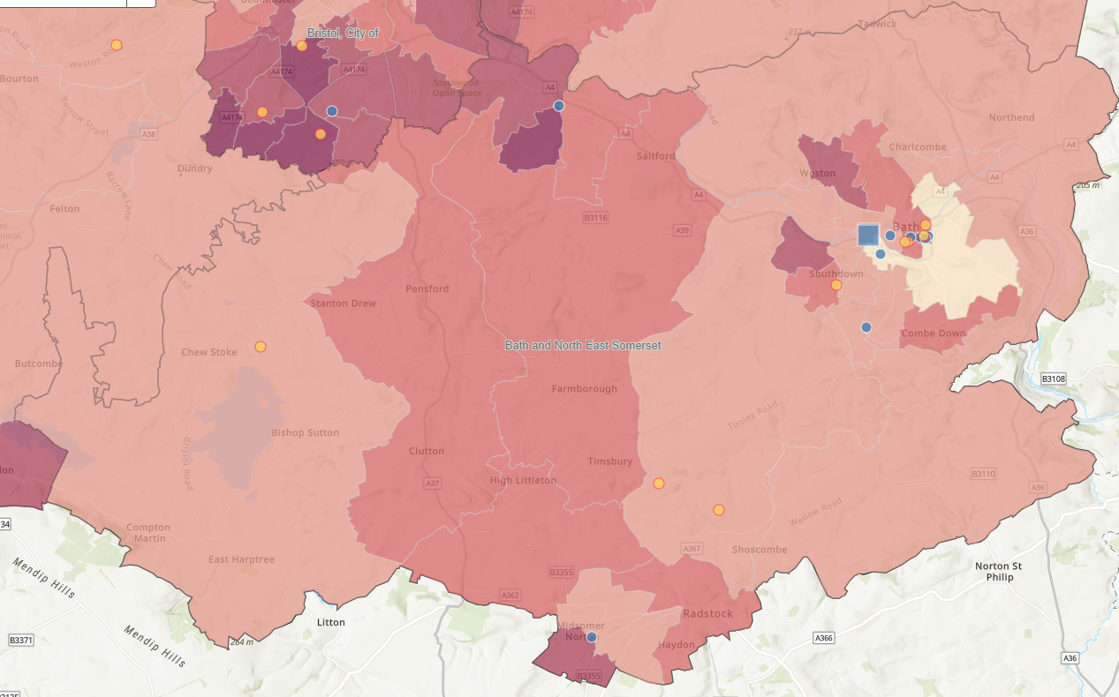
Figure 1: BANES LSEG & LTHC
Low Socio-economic group
- Twerton
  - Area is in the highest NS SeC 6-8 percentage
  - Has 2 sub areas that have a IMD rating of 1, 1 sub area with a rating of 2 and 1 sub area with a rating of 3
  - Throughout delivery period, there has only been 1 TIF project within the area, which was delivered in phase 1
- Radstock, Westfield and Midsomer Norton Redfield
  - Areas are in the 2nd highest NS SeC 6-8 percentage
  - Areas have a total of 4477 impacted people
  - No TIF focused funding
- Keysham South
  - Area is in the 2nd highest NS Sec 6-8 percentage
  - Area has 1160 people impacted people
  - Only 1 previous TIF focused project
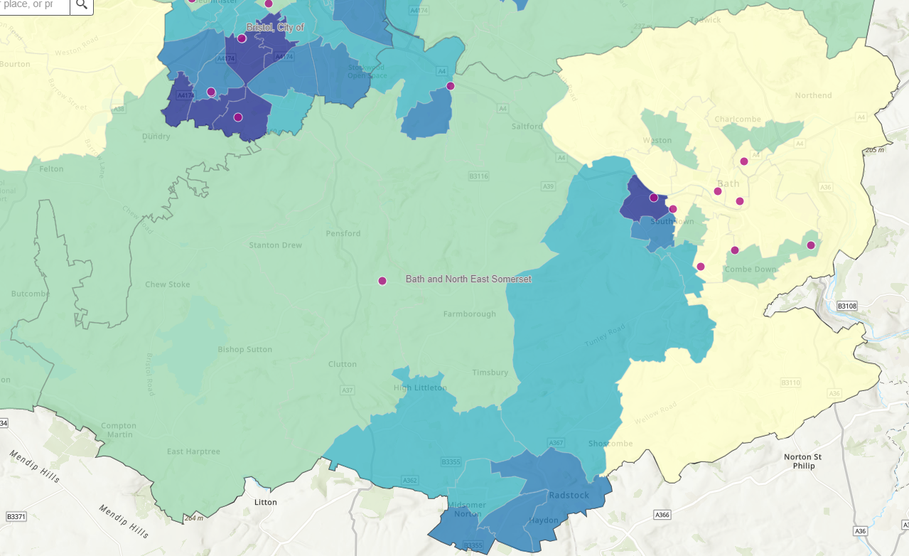
Figure 2: BANES LSEG

Bristol
Priority areas as identified by mapping and collaboration with VCFSE Partners:
- North Bristol: Lockleaze / Lawrence Weston & Avonmouth
- Inner City East: Easton / Barton Hill / Lawrence Hill / St Pauls / St George
- South Bristol: Hartcliffe & Withywood / Knowle & Filwood
Long-term health conditions & disability
- South Bristol (Highridge, Withywood, Hartcliffe & Knowle West)
  - Within the 4 areas, 6,231 people whose day-to-day activities are limited
  - Phase 3, 1 targeted project for long term health conditions funded for £1400 where delivery was focussed in a school
  - There has also only been 1 disability focussed project nearby the focus areas located in Hengrove
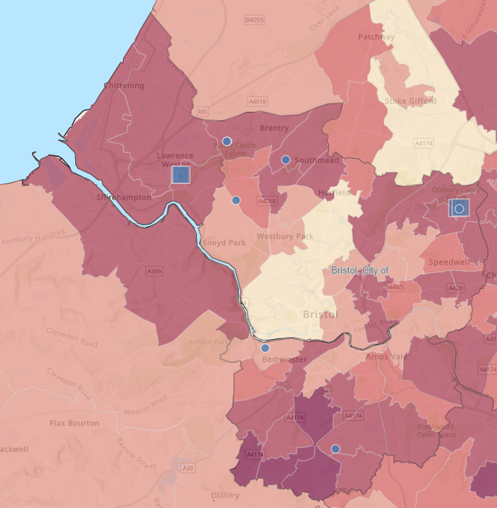
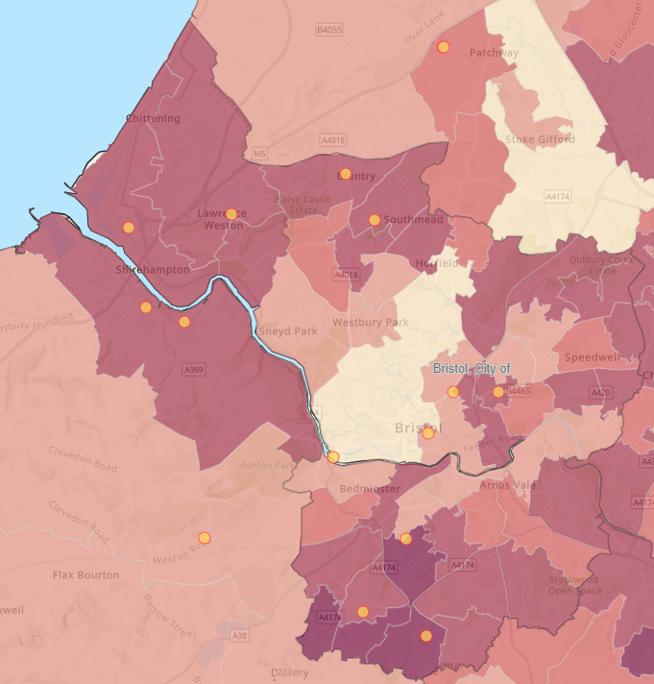
Figure 3: Bristol LTHC Figure 4: Bristol Disabled People
Low Socio-economic group
- Lawrence Weston
  - Whole of Lawrence Weston area is in highest percentage for NS SeC 6-8
  - The specific area highlighted has a IMD rating of 1, the highest of deprivation
  - No specific projects ever funded with the closest being delivered in Southmead
- Shirehampton
  - 2824 people whose day-to-day activities are limited (more 50% of ward population)
  - Not targeted projects through TIF
- South Bristol (Highridge, Withywood, Hartcliffe & Knowle/Knowle West)
  - All areas are in the highest percentage for NS SeC 6-8 and have a IMD rating of 1
  - Over the whole TIF delivery period, there have been a total of 3 projects, 2 in Knowle West, 1 in Hartcliffe
  - 1 in phase 1, 2 in phase 2, with 0 targeted projects delivered in phase 3
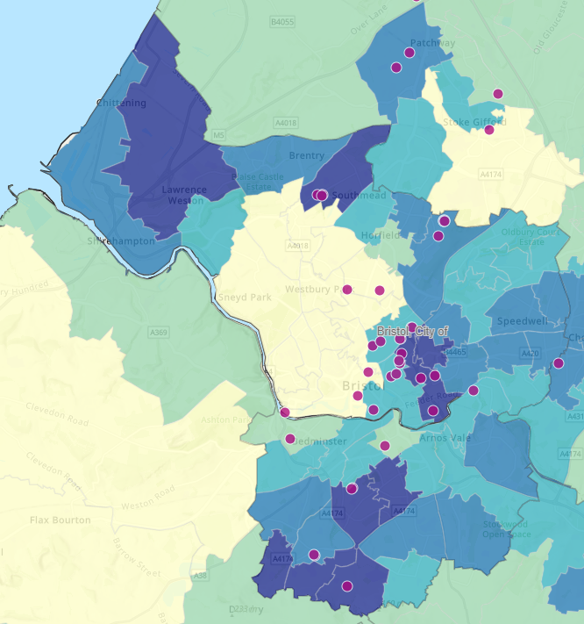
Figure 5: Bristol LSEG

North Somerset
Priority areas as identified by mapping and collaboration with VCFSE Partners:
- Weston – Super – Mare
- Worle
- Winscombe / Hutton
Long-term health conditions & disability
- Weston Super-Mare – In the highest category for Inactivity according to Active Lives Survey, apart from Clarence & hillside
  - Currently 12,151 people whose day-to-day activities are limited
  - £5000 spread across delivery in 7 different care homes with no actual support to external community – Alive Activities Ltd
  - £330 spent on health trackers (smart watches) – British Red Cross
  - No project ever funded targeting specifically for people with a disability
- Winscombe, Langford & Blagdon
  - 1619 people whose day-to-day activities are limited
  - No projects funded within the area ever through TIF (1 project close by for the eastern population of the area)
- Nailsea West
  - 1819 people whose day-to-day activities are limited
  - £330 spent on health trackers (smart watches) – British Red Cross
- Mid Worle
  - 2149 people whose day-to-day activities are limited
  - No projects funded within the area ever through TIF (1 project close by for the eastern population of the area)
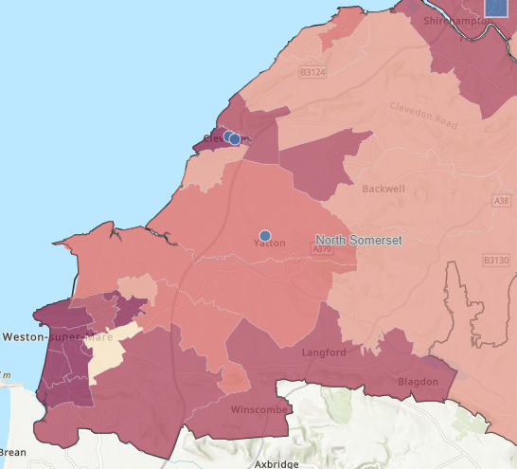
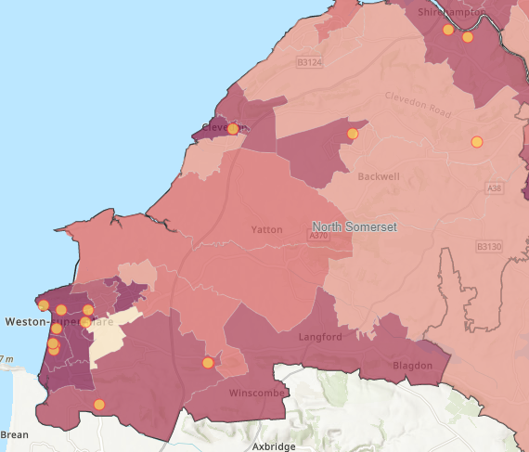
Figure 6: NS LTHC Figure 7: NS Disabled People
Low Socio-economic group
- Weston Town
  - 3004 people in NS-SeC 6-8 with this area being a 1 in IMD
  - No targeted projects in phase 3
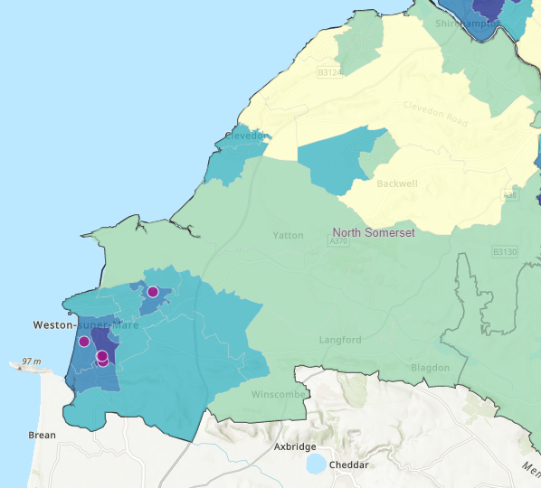
Figure 8: NS LSEG

South Gloucestershire
Priority areas as identified by mapping and collaboration with VCFSE Partners:
- Kingswood
- Staple Hill
- Patchway
- Cadbury Heath
- Yate
- Winterbourne
Long-term health conditions & disability
- Winterbourne
  - 1168 people whose day-to-day activities are limited
  - No targeted projects ever funded through TIF
- Hanham
  - 1555
  - No targeted projects through TIF
- Downend South
  - 1189
  - No targeted projects through TIF
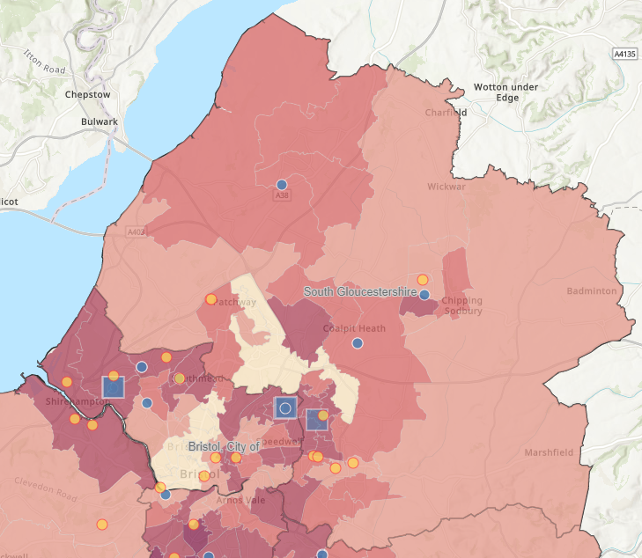
Figure 9: S Glos LTHC & Disabled People
Low Socio-Economic Groups
- Staple Hill South & Kingswood North West, Kingswood North East, Mangotsfield
  - 6067 people whose day-to-day activities are limited
  - No targeted projects through TIF
- Yate West, Yate Kingsgate, Yate South
  - 5479 people whose day-to-day activities are limited
  - No targeted projects funded through TIF
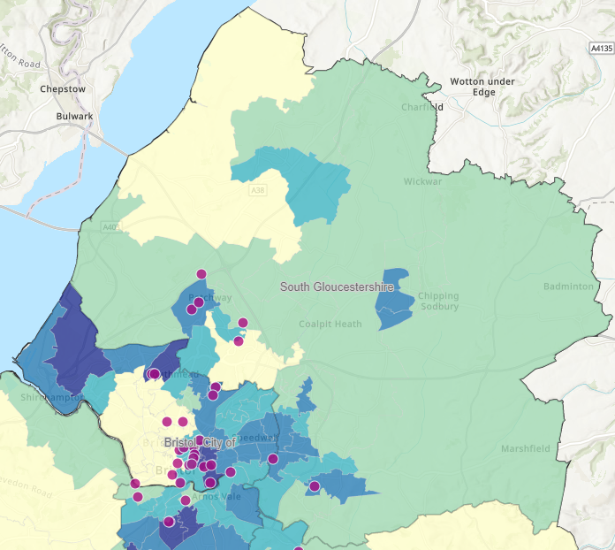
Figure 10: S Glos LSEG

