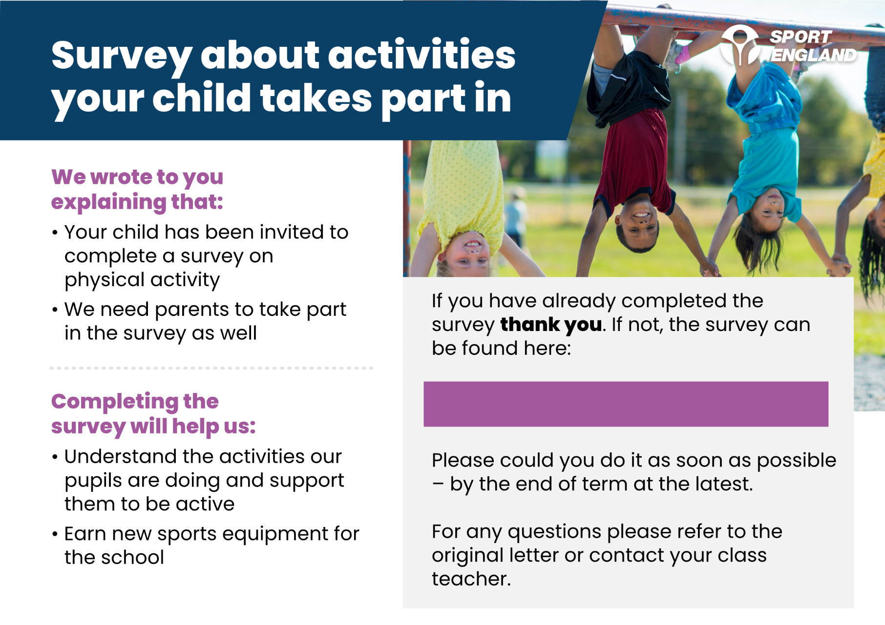

**[INSERT PARENT SHORT URL**