Active Lives:
Children and Young People

Year 1-2
Questionnaire Summary
Introduction
This document has been created for class teachers and is designed to summarise the content of the Active Lives: Children and Young People questionnaire for children in Years 1 and 2. Please note that the online questionnaire has been designed to be engaging for children to complete and therefore questions are not displayed in the same format as shown below.
A separate information sheet for class teachers has been provided to explain how to administer the survey with your class, titled Active Lives Survey for Children and Young People: Information for class teachers administering the pupil survey.
Background information is highlighted in green text for your information. This is not displayed to children.

Homepage
On entering the URL, children should see the following screen.
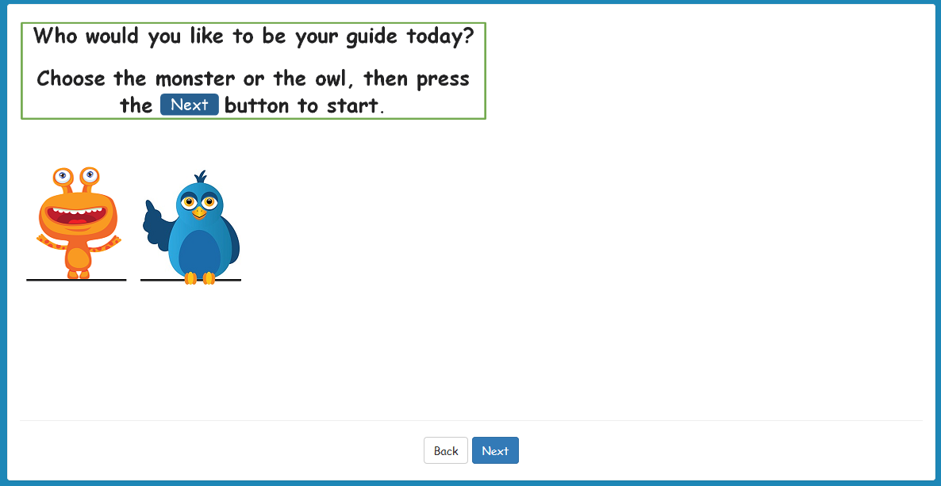
Children should just select the picture they prefer. When they have selected a character, the background behind the character will change from white to blue.

Introduction page 1
We would like to ask you some questions about sport and activities.
Use the next button to move to the next screen.
Children do not need to answer a question on this screen. Once they have read the instructions they should select the ‘Next’ button. If they wish to change their character, they can select ‘Back’.

Introduction page 2
You can read the questions
Or press the headphones button, found above in the corner of the screen, to hear the questions
When a child selects the audio icon in the top right-hand corner of the screen (headphone image shown above), the question will be read out to them. If possible, please provide children with headphones while they complete the survey so they can use this feature if they wish.

Question 1
How old are you?
Please touch the screen or click with the mouse to choose your answer.
- 5
- 6
- 7
When a child has selected their answer, the background behind the response option will change from white to blue.

Question 2
Which month is your birthday in?
- January
- February
- March
- April
- May
- June
- July
- August
- September
- October
- November
- December

Question 3
And what day in [month] is your birthday?
- 1
- 2
- 3
- …through to…
- 31
The month in the question will be automatically filled in depending on the child’s answer to the Question 2. The response options shown will depend on the month they selected in Question 2, e.g. if they selected February, only 1 to 29 will be shown.

Question 4
Which school year are you in?
- Year 1
- Year 2
If a child selects Year 2 but at Question 1 they said they were 5 years old, they will be asked:
Are you sure you are in year 2?
Ask your teacher, then press next.
And similarly if a child selects Year 1 but at Question 1 they said they were 7 years old, they will be asked:
Are you sure you are in year 1?
Ask your teacher, then press next.
When children press ‘next’ they will be shown question 4 again. They can change their answer or keep their original answer and proceed to the next question.

Question 5
Are you a boy or a girl?
- Boy
- Girl

Question 6
Have you done any of these sports in the last week?
Please choose all the sports you did
- Football
- Gymnastics
- Swimming
- Cricket
- Netball or basketball
- Rounders
- Judo/karate
- Tennis
- I did another sport
- I did no sport
Children can select more than one answer to this question. They should think about everything they have done in the last 7 days but not any longer ago.

If a child selects a sport but also selects ‘I did no sport’ a red box will appear saying ‘You can’t choose ‘I did no sports’ and sports such as [other selected answer] together. Please check your answer or speak to a teacher.’

Question 7
Do you like playing sport?
- I love playing sport
- I like playing sport
- I don’t like playing sport
- I hate playing sport
If possible children should think about sport in general, not just the sporting activities they did in the last 7 days.

Question 8
Do you find sport easy?
- Yes
- No
- I don’t know

Question 9
Have you done any of these things in the last week?
Please choose all the things you did
- Walking
- Dancing
- Running games like tag/ it/ hide and seek
- Trampoline
- Climbing frame
- Roller skating
- Scooter
- Riding a bike
- I did another activity
- I did no activities
Children can select more than one answer to this question. They should think about everything they have done in the last 7 days but not any longer ago.

If a child selects an activity but also selects ‘I did no activities’ a red box will appear saying ‘You can’t choose ‘I did no activities’ and sports such as [other selected answer] together. Please check your answer or speak to a teacher.’

Question 10
Do you like being active?
This includes things like running games, riding a bike or scooter, walking and dancing.
- I love being active
- I like being active
- I don’t like being active
- I hate being active

Question 11
Do you like swimming?
- I love swimming
- I like swimming
- I don’t like swimming
- I hate swimming
- I don’t know

Question 12
How did you get to school today?
Please choose all the ways you came to school today
- I walked
- I went in a car
- I rode a bike
- I went on a scooter
- I went on a bus
- I went on a train or tram or tube
Children can select more than one answer to this question.

Question 13
How do you feel today?

Final screen
Thank you! That is the end of the survey.
Children’s answers are automatically submitted. Once they reach this screen you or they can close the browser.

