Booking Form

Name of Candidate:
Click here to enter text.

Job Title:
Click here to enter text.

Candidate Email Address:
Click here to enter text.

Name of Your Setting:
Click here to enter text.

Address & Telephone Number of Setting:

Main Contact (Name and email):
Click here to enter text.

Session Candidate Wishes to Attend:
☐ Module 1: Date……………………………………….

☐ Module 2: Date……………………………………….

Payment Method:
☐County Council BACS
☐Direct to inspired ltd
(An invoice will be sent to the main contact)

Any Additional Requirements (dietary requirements / additional needs):

Please email to tania@binspireduk.co.uk or post to B inspired UK, 33 Newlands, Pershore, WR10 1BW

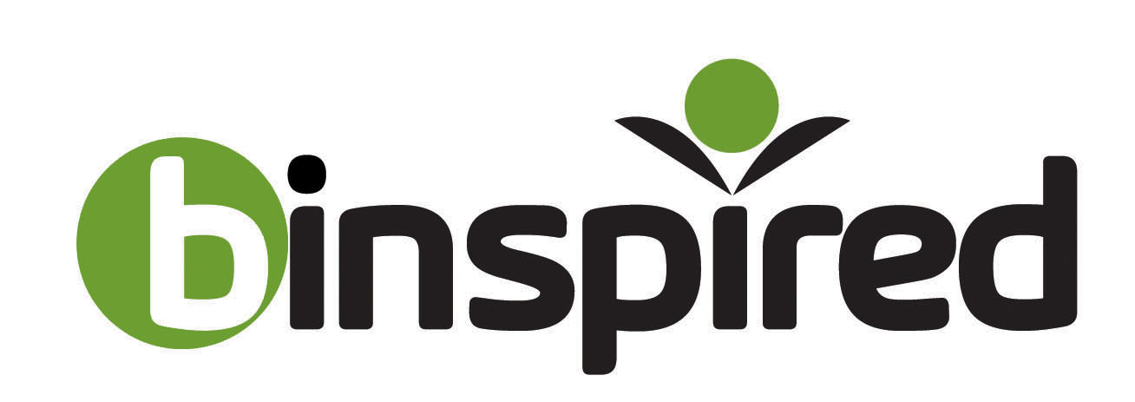 www.binspireduk.co.uk

